Exploratory Data Analysis (EDA) Report – Adventure Park Dataset
Dataset Overview
The Adventure Park dataset contains sales, reseller, product, employee, and regional information that helps analyze business performance, revenue generation, employee efficiency, and regional sales trends. This is B2B business data and the data is static.

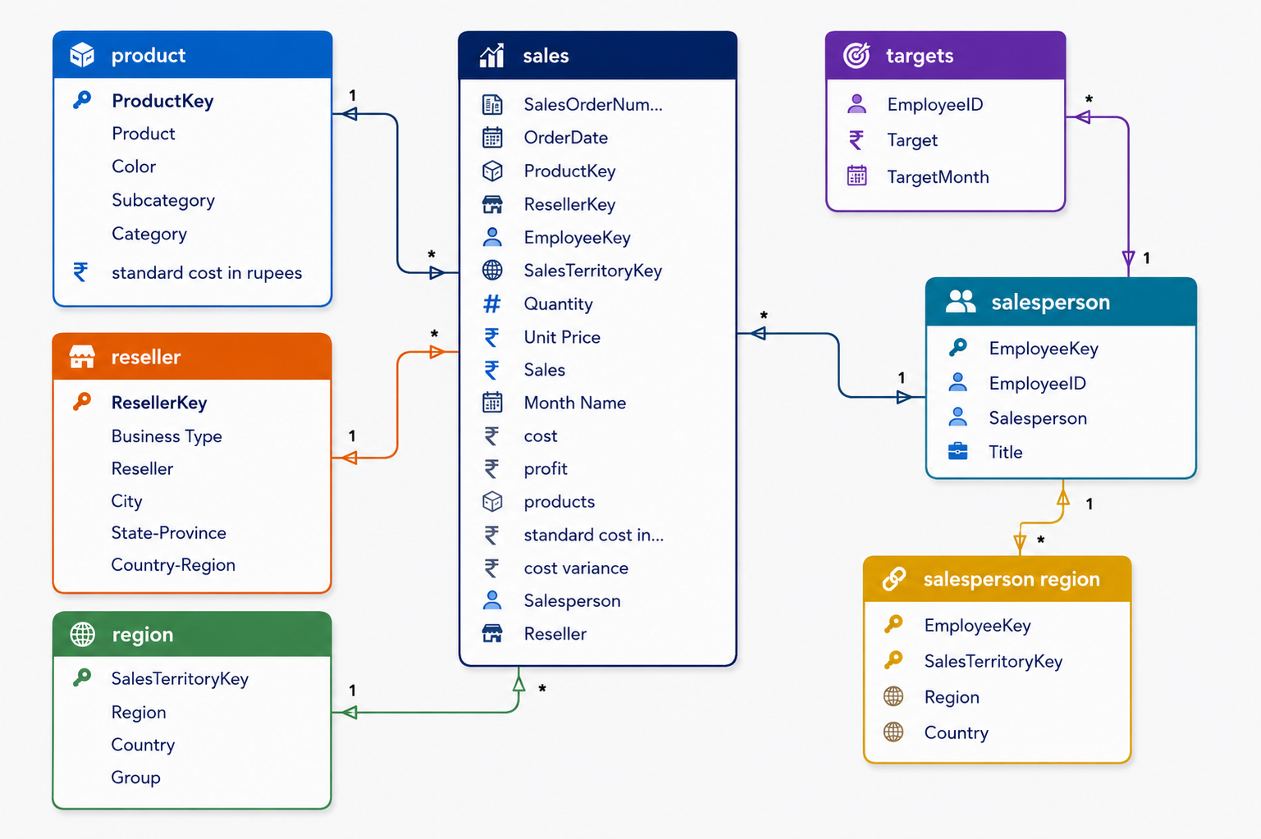

Tables Included
Table Name | Rows | Columns | Purpose
Product Table | 397 | 6 | Product and category details
Region Table | 10 | 4 | Regional and country information
Reseller Table | 701 | 6 | Reseller business information
Sales Table | 57,851 | 10 | Transaction and sales records
Salesperson Table | 18 | 5 | Employee information
Salesperson Region Table | 39 | 2 | Employee-region mapping
Target Table | 809 | 3 | Monthly sales targets

Data Cleaning & Transformation
Removed Unnecessary Columns
The following columns can be removed because they do not contribute to business analysis:
- Background Color Format
- Font Color Format
- UPN Code

Currency Conversion
All monetary values were originally in dollars and converted into Indian Rupees (₹) for better regional understanding.
Converted columns:
- Unit Price
- Sales
- Cost
- Standard Cost
- Target

Relationships Between Tables
Primary Table | Connected Table | Key
Sales | Product | Product Key
Sales | Reseller | Reseller Key
Sales | Region | SalesTerritoryKey
Sales | Salesperson | Employee Key
Salesperson Region | Region | SalesTerritoryKey
Target | Salesperson | Employee ID

Business Objectives
The dataset helps answer the following business questions:
- Which product category generates maximum revenue?
- Which region or country has low sales?
- Which salesperson performs best?
- Are employees achieving their targets?
- Which reseller contributes the highest revenue?
- What is the monthly sales trend?
- Which products are high-profit products?

Exploratory Data Analysis (EDA)
1. Sales Performance Analysis
Key Metrics
- Total Revenue
- Total Cost
- Total Profit
- Profit Margin %
- Total Quantity Sold
- Average Order Value
Formula
Profit = Sales – Cost
Profit Margin % = (Profit ÷ Sales) × 100

2. Product Analysis
Analysis Performed
- Revenue by Category
- Revenue by Sub-category
- Top Selling Products
- Low Performing Products
- Most Profitable Products
Expected Insights
- Bikes or accessories may contribute highest sales.
- Some low-selling products may require discounts or promotions.

3. Regional Analysis
Analysis Performed
- Revenue by Region
- Revenue by Country
- Revenue by State
- Low Performing Regions
Expected Insights
- Some countries or states may have very low market penetration.
- High-performing regions can be targeted for expansion.

4. Reseller Analysis
Analysis Performed
- Top Revenue Generating Resellers
- Revenue by Business Type
- City-wise Reseller Performance
Expected Insights
- Certain reseller types may drive more revenue.
- Urban cities may contribute higher sales.

5. Employee Performance Analysis
Analysis Performed
- Sales by Employee
- Target vs Achievement
- Best Performing Salesperson
- Lowest Performing Salesperson
KPI Formula
Achievement % = (Actual Sales ÷ Target) × 100
Expected Insights
- Identify employees exceeding targets.
- Provide incentives to high performers.

6. Time-Based Analysis
Analysis Performed
- Monthly Revenue Trend
- Quarterly Performance
- Year-wise Sales Growth
- Seasonal Sales Patterns
Expected Insights
- Peak sales months
- Slow business periods
- Seasonal demand trends

Important KPIs for Dashboard
Sales KPIs
KPI | Description
Total Revenue | Total business sales
Total Profit | Revenue minus cost
Profit Margin % | Profitability ratio
Total Orders | Number of orders
Total Quantity Sold | Products sold
Average Sales per Order | Revenue per transaction

Employee KPIs
KPI | Description
Employee Sales | Total sales by employee
Target Achievement % | Target completion rate
Best Salesperson | Highest sales performer
Lowest Salesperson | Lowest sales performer

Regional KPIs
KPI | Description
Best Performing Region | Highest revenue region
Lowest Performing Region | Lowest revenue region
Country-wise Revenue | Revenue comparison
State-wise Sales | Regional sales performance

Product KPIs

KPI | Description
Top Category | Highest revenue category
Top Product | Highest selling product
Most Profitable Product | Highest margin product
Low Demand Products | Products with low sales

Recommended Dashboard Pages
1. Executive Overview Dashboard
Contains:
- Total Revenue
- Total Profit
- Profit Margin
- Orders
- Monthly Trend
- Top Category
Suggested Visuals
- KPI Cards
- Line Chart
- Donut Chart
- Bar Chart

2. Sales Analysis Dashboard
Contains:
- Sales Trend
- Region-wise Sales
- Country-wise Sales
- Profit Analysis
Suggested Visuals
- Map Visual
- Area Chart
- Clustered Bar Chart

3. Product Dashboard
Contains:
- Category Performance
- Sub-category Analysis
- Product Profitability
Suggested Visuals
- Treemap
- Bar Chart
- Matrix Table

4. Employee Performance Dashboard
Contains:
- Employee Sales
- Target Achievement
- Top Employees
- Underperforming Employees
Suggested Visuals
- Gauge Chart
- Column Chart
- KPI Cards

5. Reseller Dashboard
Contains:
- Top Resellers
- Business Type Performance
- City-wise Revenue
Suggested Visuals
- Funnel Chart
- Bar Chart
- Pie Chart

Suggested Power Query Measures (DAX)
Total Revenue
Total Revenue = SUM(Sales[Sales])
Total Cost
Total Cost = SUM(Sales[Cost])
Total Profit
Profit = [Total Revenue] - [Total Cost]
Profit Margin
Profit Margin % = DIVIDE([Profit],[Total Revenue],0)
Total Orders
Total Orders = DISTINCTCOUNT(Sales[Sales Order Number])
Total Quantity
Total Qty = SUM(Sales[Qty])
Average Order Value
Average Order Value = DIVIDE([Total Revenue],[Total Orders],0)
Target Achievement
Target Achievement % =
DIVIDE([Total Revenue],SUM(Target[Target]),0)

Business Insights Expected
Possible Insights
- Certain categories generate maximum revenue.
- Some states or countries contribute very low sales.
- A few salespersons contribute major business revenue.
- Some resellers generate consistently high profits.
- Sales may peak during specific months.
- Profit margins vary significantly across categories.

Recommendations
Business Recommendations
- Focus marketing on high-performing regions.
- Improve strategies in low-sales regions through promotions and reseller expansion.
- Reward high-performing employees and train underperforming teams.
- Promote high-profit products instead of only high-sales products.
- Reward top-performing employees.
- Promote high-profit products more aggressively.
- Remove or redesign low-demand products.
- Increase reseller partnerships in profitable cities.

Conclusion
- The Adventure Park dataset is highly suitable for:
- Sales analysis
- Profitability analysis
- Employee performance tracking
- Regional performance analysis
- Product category evaluation
- Business decision-making dashboards

